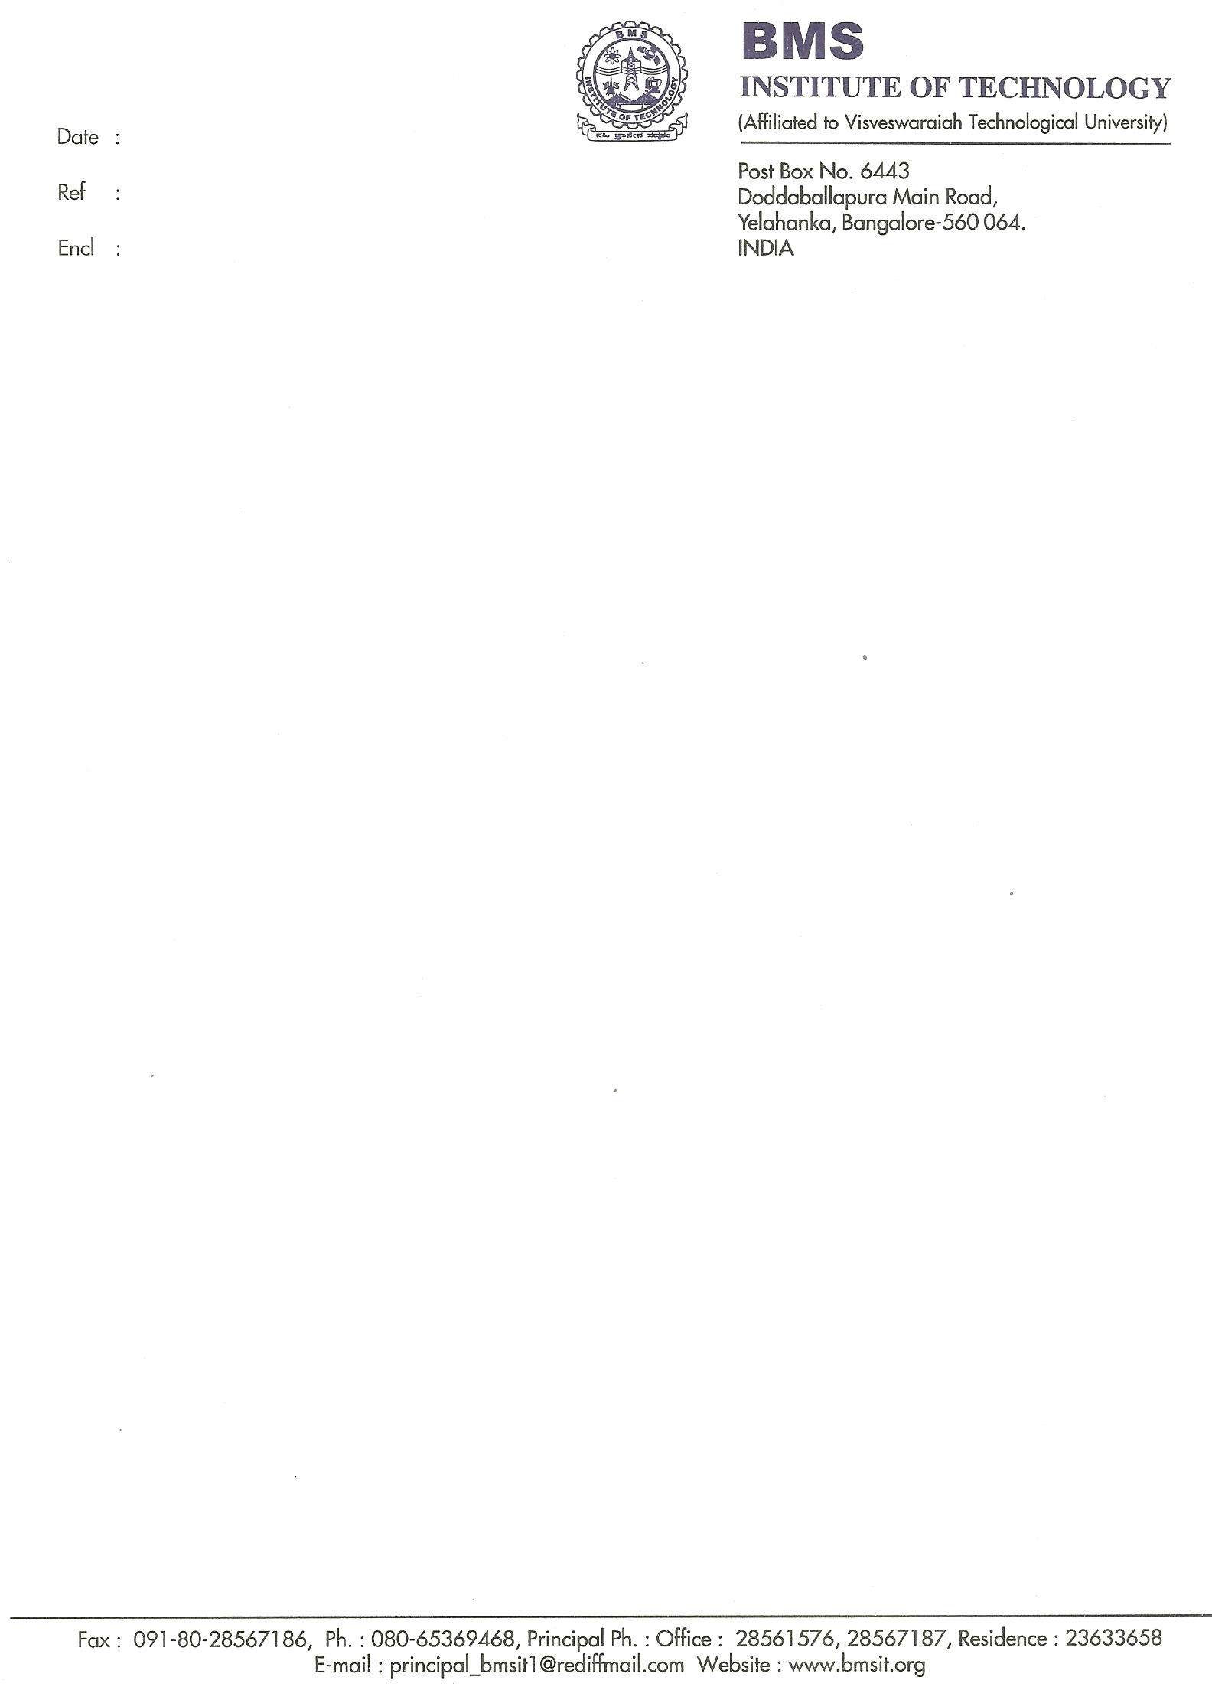

15/2/2011

Letter of Recommendation

As the Head of the Department of Telecommunication Engineering, I have had the pleasure of knowing Mr. Venkatesh Kulkarni (1BY04TE052) throughout his engineering course. He is a truly hardworking student and was an extremely positive asset to our college. I would like to take this opportunity to highly recommend Mr. Venkatesh for your masters program.
All through his engineering career, he has shown excellence in academics and has been honored First Class Distinction in his Bachelor’s degree. In the college of around 300 students in 2008 batch, he has engineered with honors in the top 10%.
He had carried out a successful project in developing Automatic guided ship using Microcontroller, which earned overwhelmingly positive reactions from the faculty and it was appreciated as one of “The Best Project” for that academic year 2008 by the internal professor. He had excellent rapport with the faculty and earned their confidence not only by securing good marks in their respective subjects but also by showing immaculate reverence. Apart from his ability about himself, he has always been setting an example for his mates and inspiring them in the right way.
His passion for cricket is worth mentioning which he represented at Inter- department level and won numerous tournaments. Looking at his present bent of mind, he will thrive in a competitive environment as he has done always, be it as a part of a group or individually.
If I can be further assistance regarding this candidate, please do not hesitate to contact me by e-mail and I wish him well in his academic endeavors.

Sincerely,
Mallikarjuna Gowda H S
Asst.Prof & HOD, Dept. of Telecommunication
B.M.S. Institute of Technology
E-mail: cpmallikarjuna75@yahoo.co.in

